**Weekly report**

A tensorflow implementation works!

We have successfully implemented a very simple neural network with one convolution layer in tensorflow.

The system is not training with any significant accuracy, but we are confident this is a result of the simplicity of the network rather than the network not working.

We have also been able to implement the tensorflow one-hot function, which automatically and very efficiently generates one-hot vectors.

In addition, we have implemented the tensorboard visualisation tool. This report will focus on the results obtained from tensorboard for a simple neural net containing no convolution layers.

For this neural net, we ran four different learning rates: 0.0001, 0.001, 0.01, 0.1.

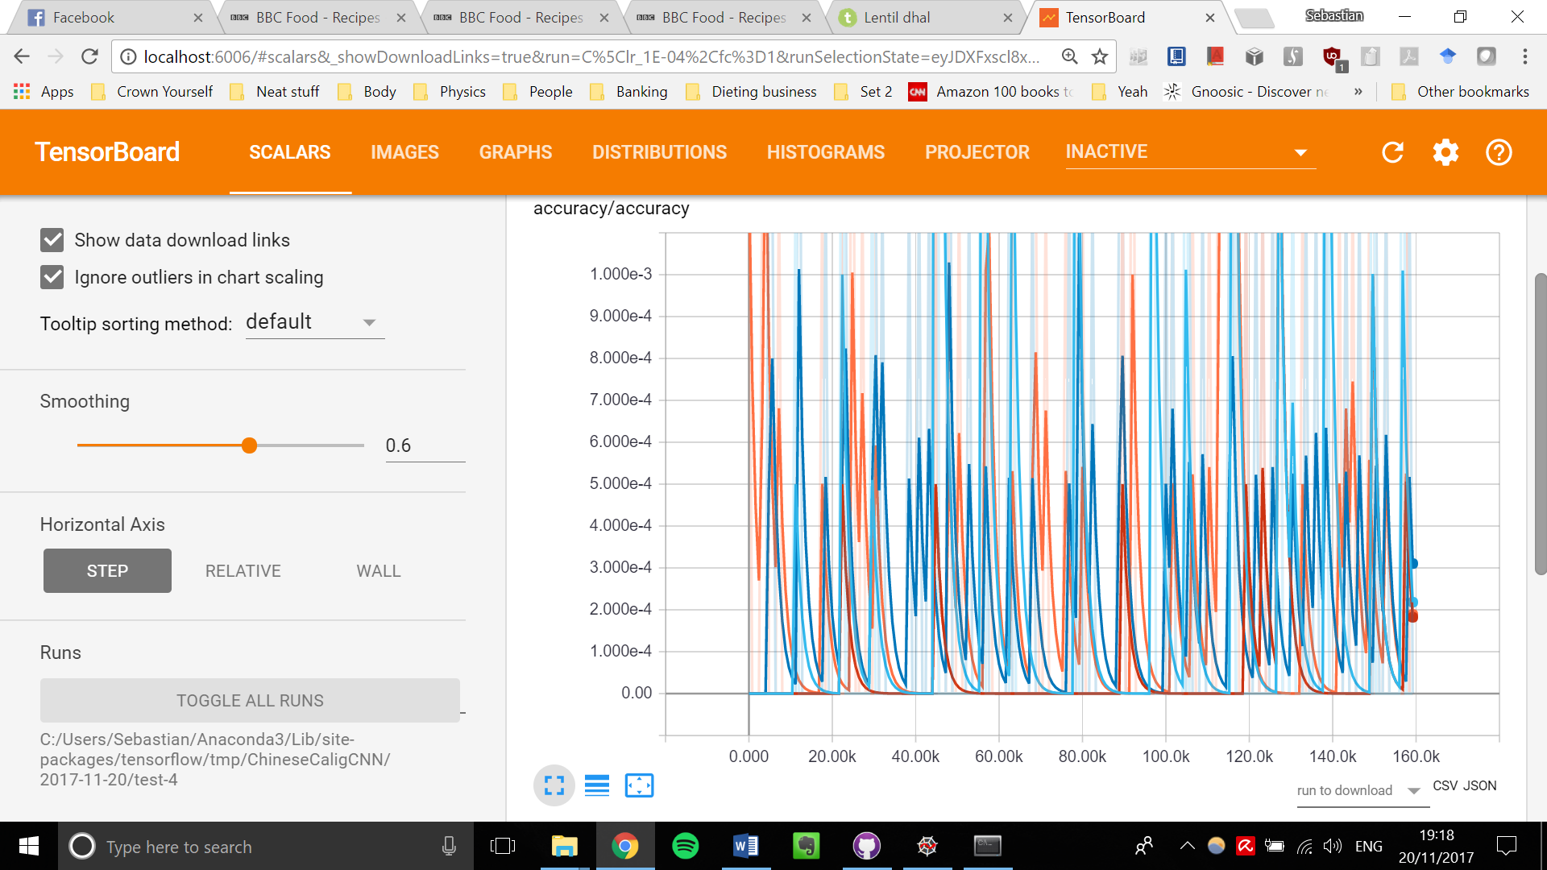

Figure : Accuracy over iterations for each method. Clearly there is no significant gain in accuracy, especially since the test set is not randomly shuffled.

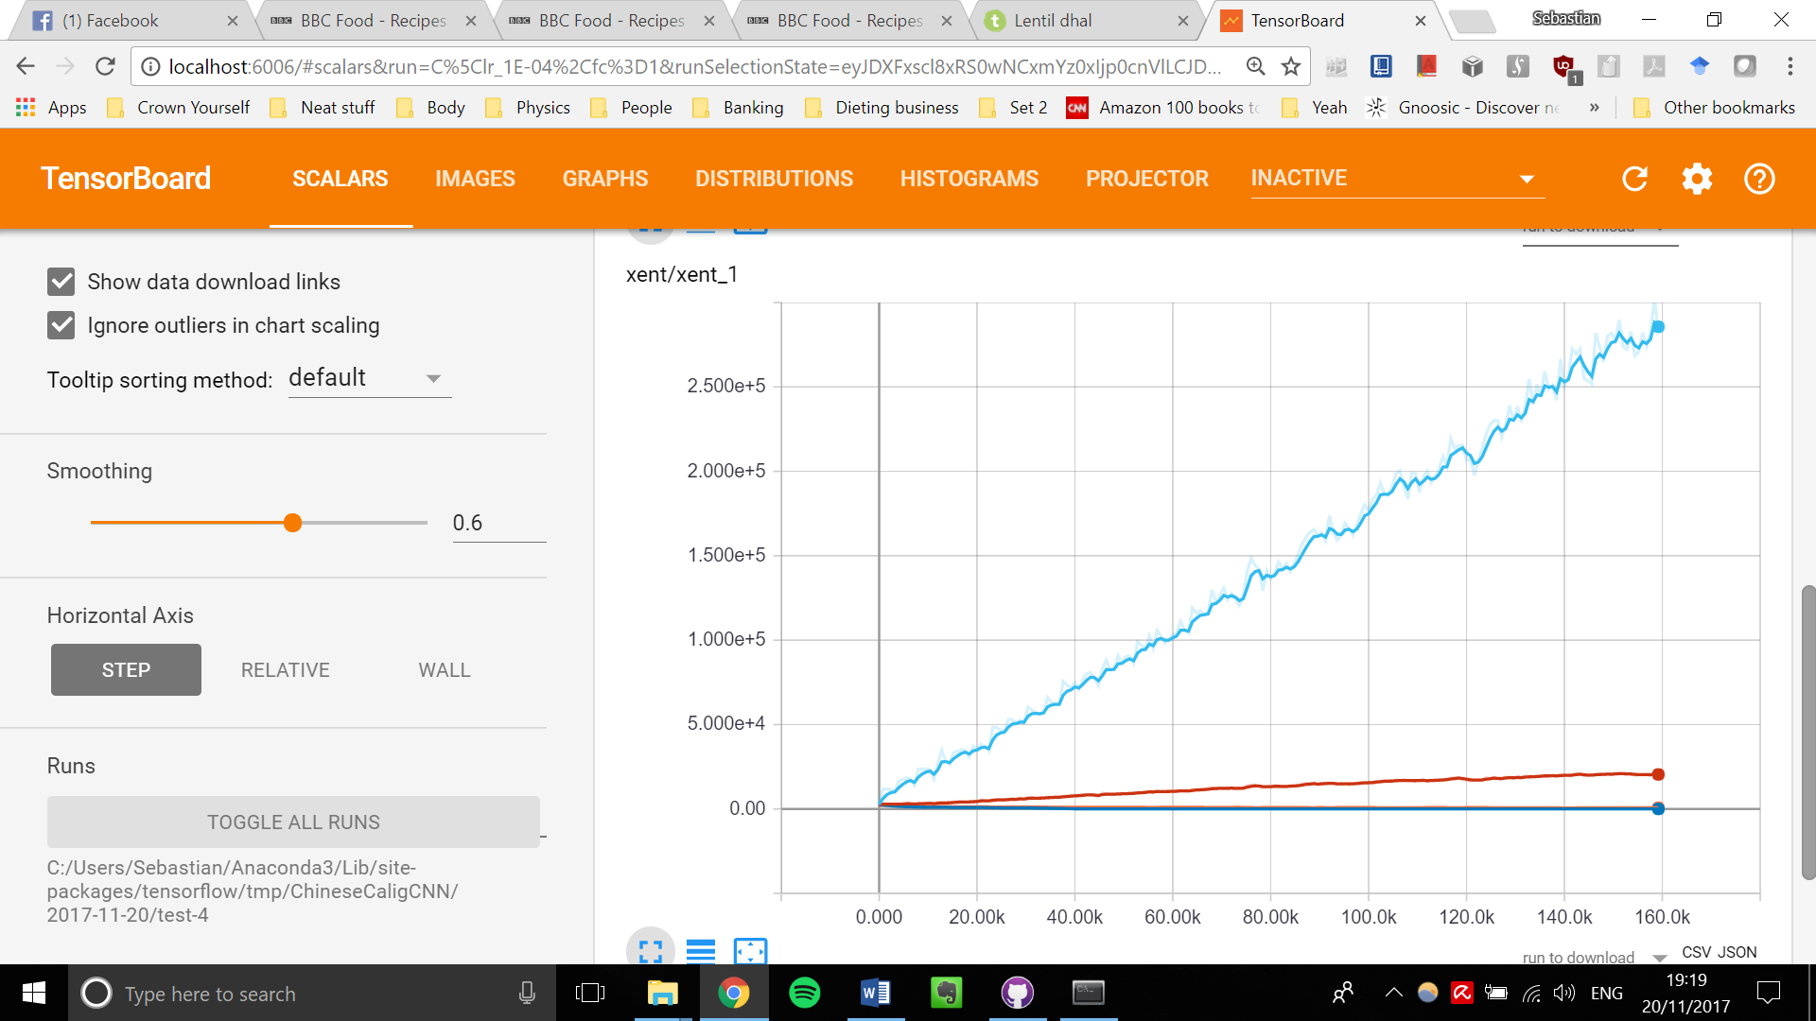

Figure : Cross entropy over iterations. Clearly one learning rate outperforms the others (the greatest learning rate decay, 0.1).

http://localhost:6006/data/plugin/images/individualImage?ts=1511196939.6167603&run=C%5Clr_1E-02%2Cfc%3D1&tag=input%2Fimage%2F2&sample=0&index=9http://localhost:6006/data/plugin/images/individualImage?ts=1511196939.6167603&run=C%5Clr_1E-02%2Cfc%3D1&tag=input%2Fimage%2F1&sample=0&index=9

Figure : Tensorboard produces example images (two here) from the inputs to check the inputs are correct.

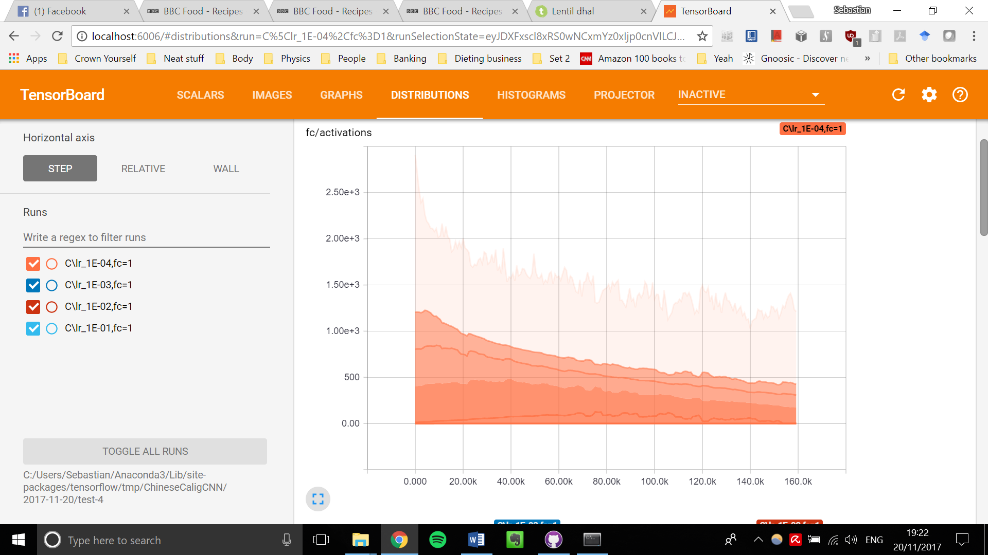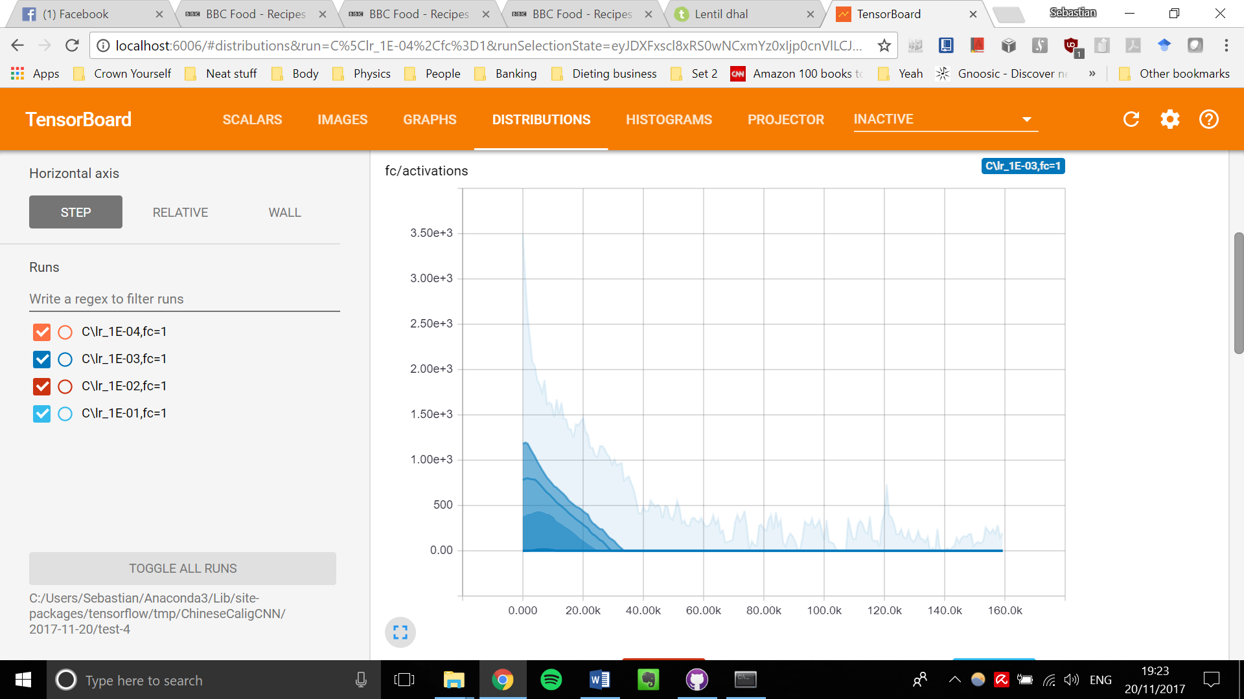

Figure : Change in full connected layer activations over iterations for two different learning rates.

Tensorflow produces graphs of any output you want. Here it automatically produced outputs of the activations for each learning rate, the weights, and the biases (weights and biases not shown).

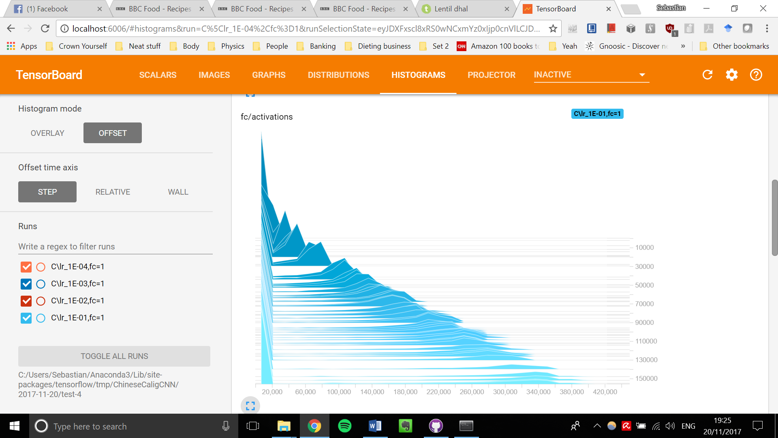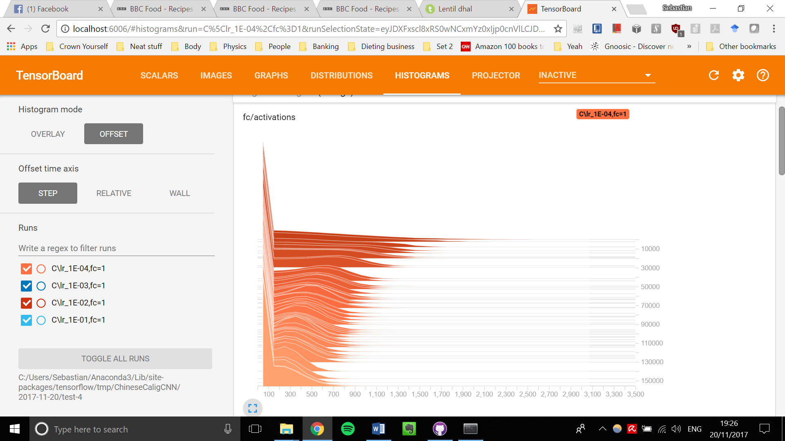

Figure : Histogram of the change in activation over iterations for two different learning rates.

These graphs are not showing much information in of themselves. Our main purpose here is to show the power of the tensorboard visualisation tool.

Our two main problems are that we are not randomly shuffling our dataset (we need to implement the dataset api to do so) and our network is simply not complex enough for the number of classes we want to test.

Another advantage of tensorflow is that it can map out your neural network architecture, as in Fig. 6. This shows the size of each tensor going to each function, and how the functions interlink.

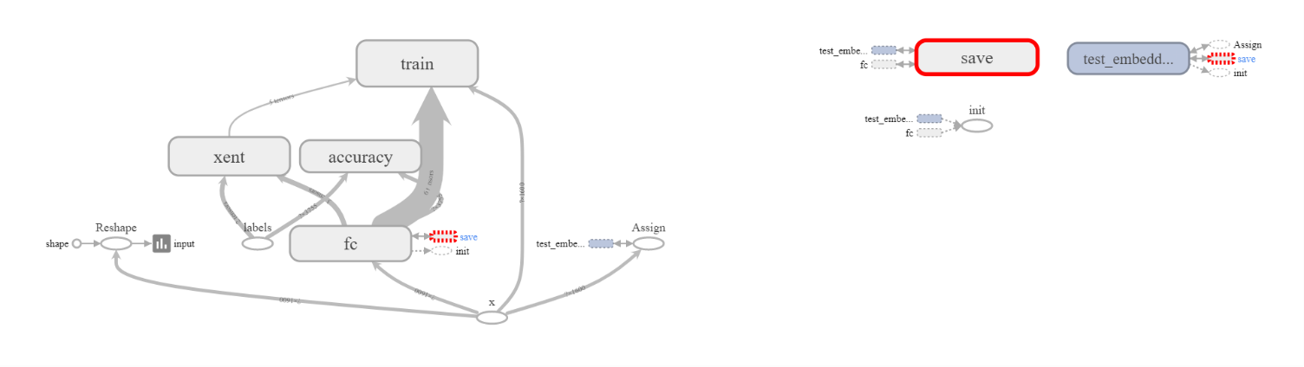

Figure : Graph of neural net architecture

This graphical display of the network architecture even allows you to expand each function such as the cross-entropy, and show in detail how it works.

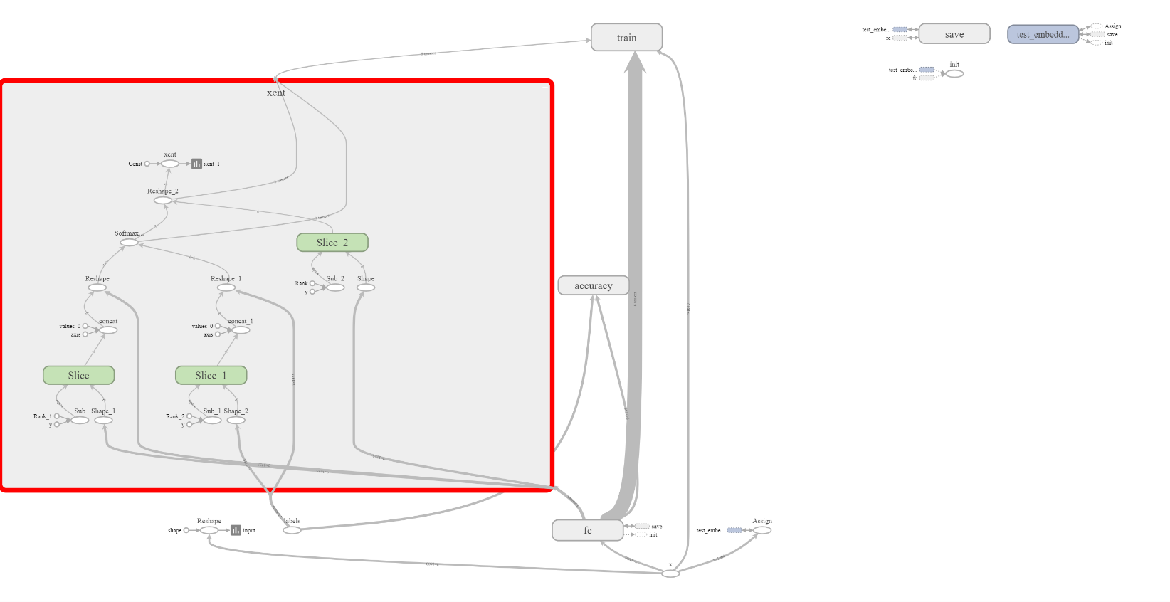

Figure : The cross-entropy ('xent') box from Fig. 6 expanded to show its inner workings.

The final tensorboard feature is a visualisation of how the neural net groups the classes in a 3D space (using dimension-reduction techniques such as PCA and t-SNE). We have been unable to implement this so far and will focus on improving the functionality of the network before implementing this visualisation.

**Action points for the next week**

1. Implement the dataset api (a part of tensorflow) so that we can batch our files the proper tensorflow way. This will let us shuffle our files and perform more operations on them. This would be the final step for a ‘tensorflow implementation’ of our net.

2. Vary the kernel size, convolution layer sizes, numbers of convolution layers etc (general network architecture) to see how these affect our data.

3. Increase the complexity of the network, doing point 2) for each increase in complexity.

4. Implement the ‘embedding’ visualisation in tensorboard which allows us to visually see how classes are grouped over time.

*Other*

We went to a talk about using machine learning in atmospheric science to properly calibrate devices measuring temperature, and particulate levels in the air. It became apparent to us how new the field is because we found we could contribute and offer some ideas to the lecturer afterwards.